[2012]
[Team Assignment 01] | Team 02 – The HIT


Class K15T2 | SOFTWARE PROJECT MANAGEMENT PLAN

Revision History
Date | Version | Description | Author
6/3/2011 | 1.0 | Consume Team member’s tasks | Thanh Giang

- Document description
This section describe who the intended audience is for the document, and to help them navigate and use the document
  - Purpose and audience: Describe who the intended audience and organizations are and what they might use the document for.
  - Document organization: Describe the overall organization of the document. List the major sections of the document and describe what concerns each section addresses.
  - Common notation: List any notation that will be used throughout the document.
  - Terminology and definitions: Define any terms used throughout the document and provide context for terminology.
  - References and relevant document: List any other relevant documents that the reader might need to refer to, and most importantly, describe their relationships to this document and why the reader might want to (or need to) refer to them.

- Project overview
  - Purpose
This document provides a high level overview of the evolving technical architecture for the Sales System of a retail chain using a loyalty card point system. It also provides a high-level description of the goals of the architecture, the use cases support by the system and architectural styles and components that have been selected to best achieve the use cases.
In addition to these views, this architectural description will:
- Identify the candidate patterns and tactics that will become the architecture design of the system.
- Frame the architectural design activity, begin with the given technical constraints and the structures
- Identify patterns generally suit the needs described in the product description based upon the quality attribute scenarios
- Identify tactics we apply to further refine the initial decomposition of the system and promote the necessary quality attributes.
The architecture has a set of guiding principles as well as known criteria and constraints that shape the proposed architecture. It is intended to capture and convey the significant architectural decisions which have been made on the system.
The development team can use this document to review the architecture of the system. The Architecture document will be also useful for future development teams.

  - Scope
The project will aim to develop a sale system for Company A, a retail chain (hereinafter, the system) in conjunction with its launch of a point service.

The system consists of a head office server, located at the head office, and the POS terminals placed at store cashiers. The head office server and the POS terminals are connected to each other via a network. Products sold at stores have bar codes attached which indicate the product codes. These bar codes can be read with bar code readers of POS terminals. Customer who have become point service members are issued point cards, which bear bar codes indicating their member numbers, and when they purchase products with cash, they are awarded points based on the amount of their purchase.
For each product, its standard price, common to all stores, is set as a part of the product data. Each store, however, can set and use its own actual retail price instead of the standard price during the limited period specified be each store. The actual retail price must be set in advance, and it cannot be charged in the middle of the specified period.
Products are classified into product types such as food, general merchandise, etc. Not all stores carry every product type, and the range of product types carried is designated for each store.
Hệ thống được xây dựng để kết nối mạng LAN các cửa hàng và head office nằm trong cùng một tòa nhà. Both the head office server and the POS terminals are equipped with a Database, and both the head office server Database and the POS terminal Database can be accessed during the sales operation. Riêng Head office sẽ có them một server database phụ, chỉ làm nhiệm vụ update thông tin
Moreover, in addition to the sales operation, Việc đồng bộ dữ liệu giữa các cửa hàng và the Head office sẽ được chia làm hai loại. Một do người admin tự đồng bộ bằng tay vào cuối ngày và đầu ngày, thường là đồng bộ tất cả các thông tin. Hai là đồng bộ do hệ thống tự động sau mỗi 5 phút đối với các thông tin về khách hàng và các thông tin bán hàng như bills để the system is also capable of performing the statistical analysis on the sales records of all stores in near real-time manner.

  - Stakeholders

Stakeholders | Organizations | Interaction
Customers | None
Staffs | Company A
Cashiers | Company A
Administrator | Company A
HIT Team | Van Lang University

- This section describes the project and its purpose and scope.
- Describe why the system is being built.
- Describe business, organizational, mission, or marketing concerns that are relevant to the project.
- List the relevant stakeholders, their organizations, and how they will interact with the system.

- Architectural drivers
  - High-level Functional Requirements
Use Case ID | Use Case Name | Important Level | Difficulty Level

System Management
UC_SM01 | Add New User | High | Medium
UC_SM02 | Search/ View User List | Medium | Low
UC_SM03 | View User Log | Low | High
UC_SM04 | View User Detail Information | Normal | Low
UC_SM05 | Assign Authorize | High | High
UC_SM06 | Update User Information | Normal | Medium
UC_SM07 | Sync Information | High | High

Product Management
UC_PM01 | Add New Product | High | Medium
UC_PM02 | Search/ View Product List | Medium | Low
UC_PM03 | View Product Detail Information | Medium | Low
UC_PM04 | Choose Category | Medium | Low
UC_PM05 | Update Product Information | Medium | Medium

Record Management
UC_RM01 | Add New Record | High | High
UC_RM02 | Search/ View Record List | Medium | Low
UC_RM03 | View Record Detail Information | Medium | Low
UC_RM04 | Print Record | Medium | Medium

Retail Stores Management
UC_RSM01 | Add New Store | High | Medium
UC_RSM02 | Search/ View Store List | Medium | Low
UC_RSM03 | View Store Detail Information | Medium | Low
UC_RSM04 | Update Store Information | Medium | Medium

Category Management
UC_CM01 | Add New Category | High | Medium
UC_CM02 | Search/ View Category List | Medium | Low
UC_CM03 | View Category Detail Information | Medium | Low
UC_CM04 | Update Category Information | Medium | Medium

Customer Management
UC_C01 | Add New Customer | High | Medium
UC_C02 | Search/ View Customer List | Medium | Low
UC_C03 | View Customer Detail Information | Medium | Low
UC_C04 | Update Customer Information | Medium | Medium
UC_C05 | View Customer Point Log | High | Medium
UC_S01 | Statistic Information | Low | High
UC_C01 | View Point | High | Medium

    - Use-case Diagrams

Actor | Description
Administrator | Responsible for manage user of the system such as: Create new, assign authorize. He can also sync information between
Staff | Responsible for manage information of products, categories, customer, retail stores and they can statistic sales by many criterion
Cashier | Responsible for check bills (records)
User | Includes Staff, cashier and admin: they can use basic function like: log in, logout, change password
Customer | There are some touch LCD screens in the store. Customer can touch in those LCD to know their point log while they enter the store

Note Table:
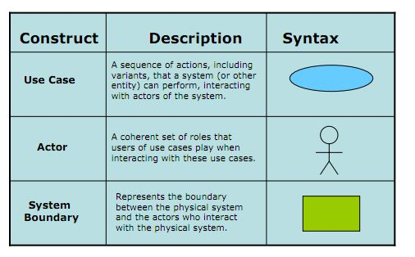
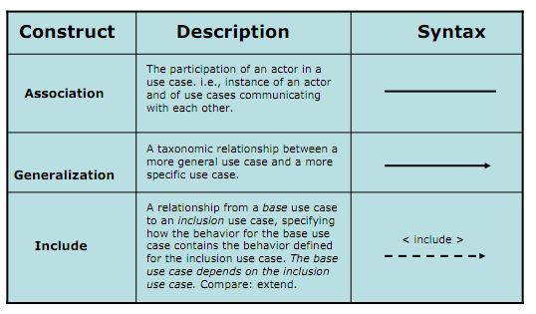

Level 1 – Retail Sales System

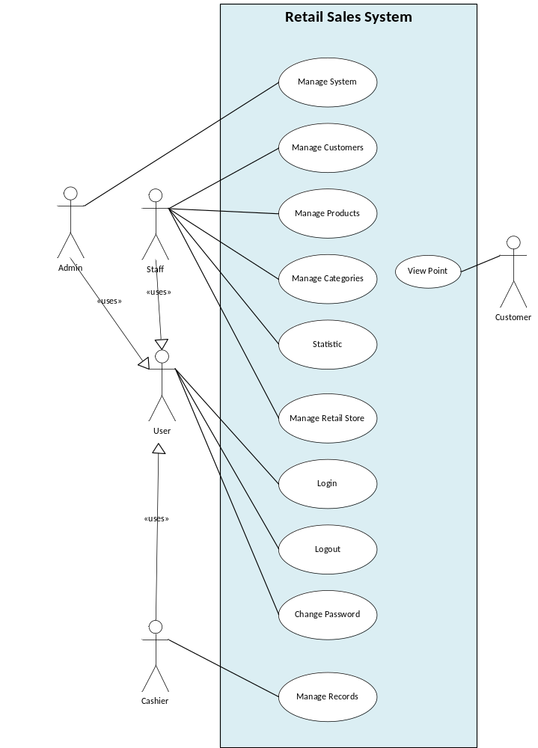

Level 2 - System Management

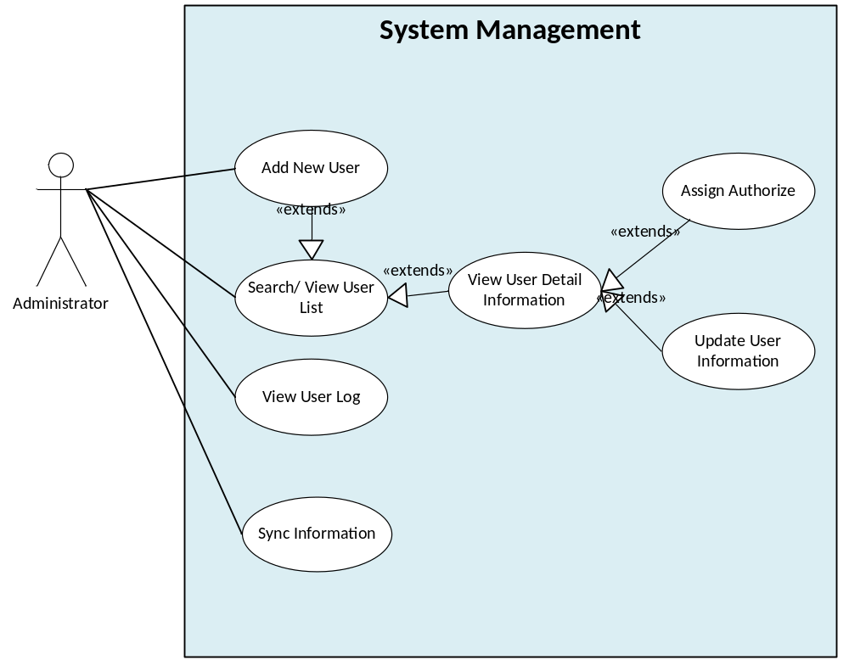

Level 2 - Customer Management

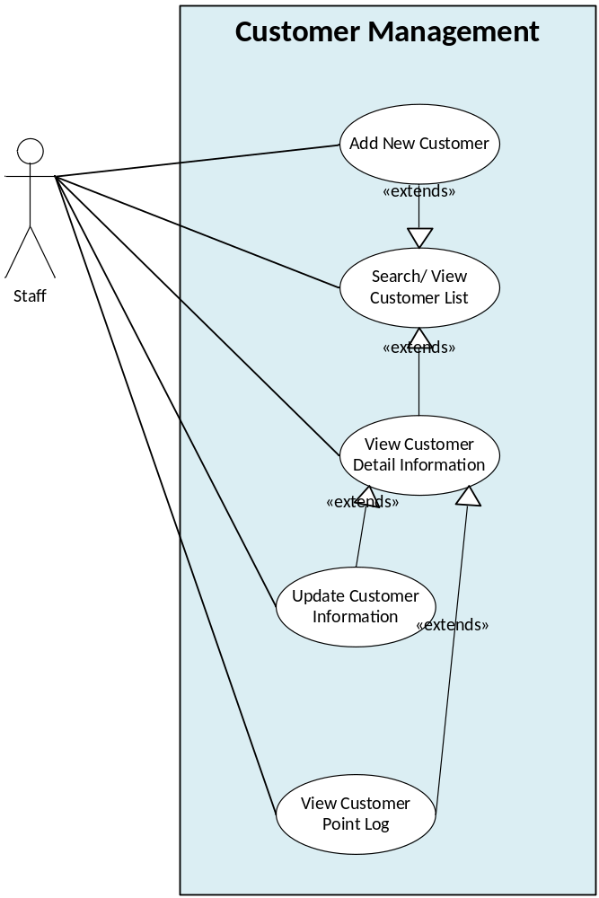

Level 2 - Product Management

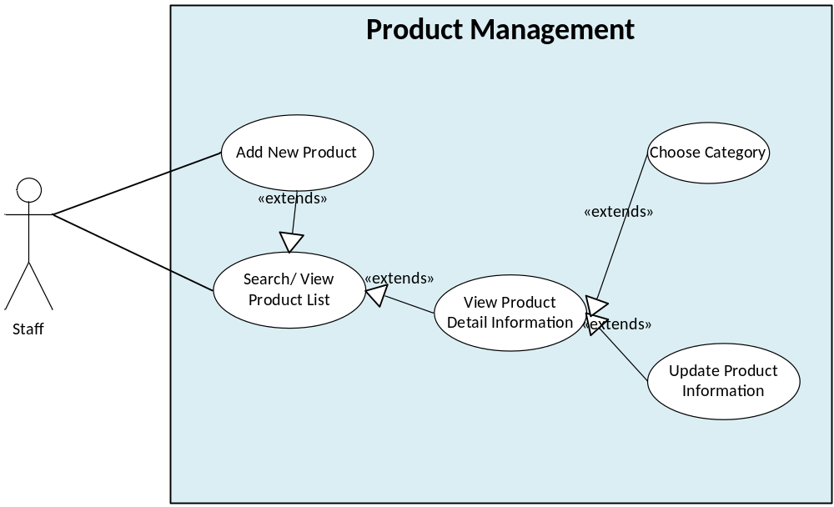

Level 2 - Category Management

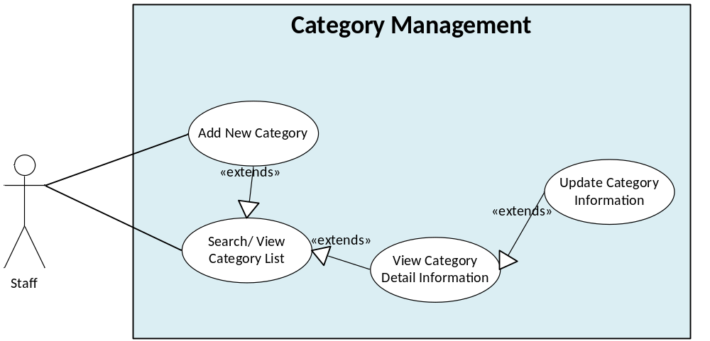

Level 2 - Record Management

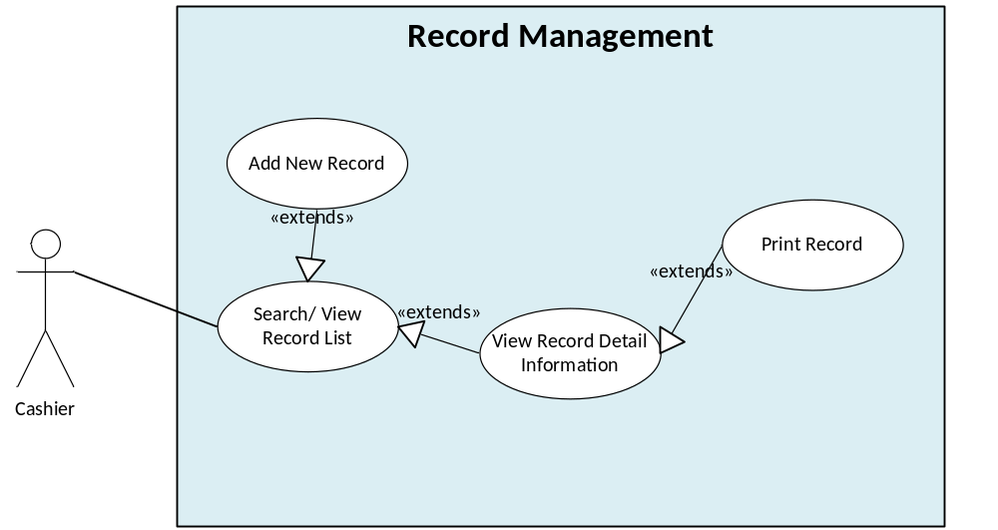

Level 2 - Retail Stores Management

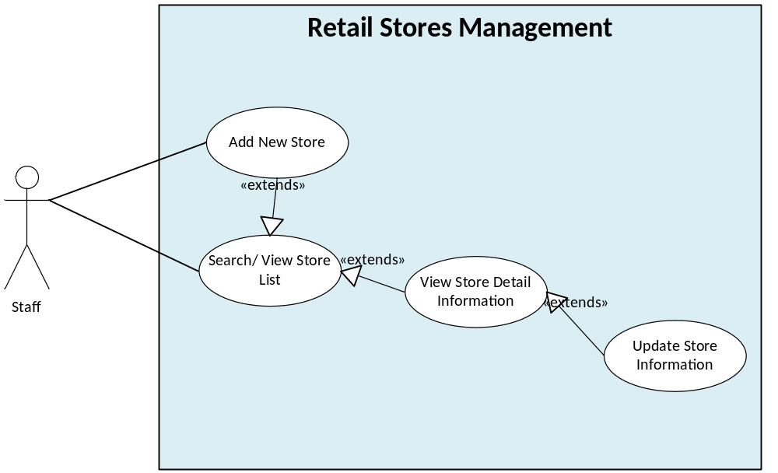
  - Constrains:

    - Business Constrains:
Consideration | ID | Business Constraints.
Cost limitations. | BC01 | None
Schedule limitations. | BC02 | 6 weeks
Mandatory regulatory restrictions and demands. | BC02 | Customers who have become point service members are issued point cards. Points can be used in all stores.  The member the either pays with cash, points, or a combination of the two
Legal restrictions and demands. | BC03 | None
Market restrictions and demands. | BC04 | The actual retail price must be set in advance.
Organizational restrictions and demands. | BC05 | One team with 6 members
Logistical issues. | BC06 | None

    - Technical Constrains:
Consideration. | ID | Technical Constraints
Computer operating system(s). | TC01 | None
Computer platform(s). | TC02 | None
Computer languages(s). | TC03 | None
Peripheral or network hardware. | TC04 | Database server
Commercial hardware or software products. | TC05 | Bar code readers  Keyboard
Tools and methods. | TC06 | SQL Database Server
Protocols, interfaces, standards. | TC07 | TCP/IP protocol
Legacy hardware and software. | TC08 | None

  - Quality Attributes

Quality Attribute Ranking Table
Quality Attribute | Important (base on customer) | Difficult level (to implement) | Priority
Performance | High | High | High
Availability | High | High | High
Usability | Medium | Low | Low
Security | Medium | Medium | Medium

    - Performance:

This is sales system; we must always ensure that customer service was not delayed. Intervals such as scan the point card, bar code scanning, displaying results... will be done in the shortest time possible to avoid the dissatisfy customer. Things that need attention are: increased client response time, reduced throughput, and server resource over utilization. Ensure that you structure the application in an appropriate way and deploy it onto a system or systems that provide sufficient resources.
Example of Performance Attribute: Users initiate 100 transactions per minute at 100 POS terminal under overload operations, and these transactions are processed with an average latency of two seconds.
Portion of scenario | Possible values
Source | User
Stimulus | 100 transactions per minute at 100 POS terminal
Artifact | System
Environment | Overload operation
Response | These transactions are processed
Response Measure | 2 seconds

    - Availability:
This system has two servers located at the head office server and POS terminal, if the failure occurs at head office server or the network; we need the system still available and working normal at the POS terminal.
Example of Availability Attribute: The temporary failure of the head office server, the POS terminal will be still working securely. The POST terminals can carry out the sales operation efficiently using locally stored data as much as possible.

Portion of scenario | Possible values
Source | Head office database
Stimulus | Temporary failure of the head office server
Artifact | System
Environment | Normal operation
Response | To be still working securely and carry out the sales operation efficiently using locally stored data.
Response Measure | No down time

- In this section describe the architectural drivers for the system.
- At a minimum, list the high-priority or critical drivers for the system
- The architectural drivers can be listed in separate sections enumerated as high-level functional requirements, technical constraints, business constraints, and quality attribute requirements.
- Make sure to list the priority of the architectural drivers.
- System context
- The system context is the first step in design and should include at least one context drawing
- In addition to the context drawing, include prose that describes the scope of the system being described by showing its relationship to external entities like systems, peripherals, organizations, and stakeholders as necessary to describe the context drawing.
- Describe the relative perspective of the context drawing or drawings.
- Level X decomposition
- Decomposition description: Describe what is being decomposed and relate it back to the context drawing. Describe the perspective of the decomposition.
- Primary representation(s): Include one or more drawings (or views) that represent the decomposition of the system
- Description and rationale:
  - Describe the primary representation and include rationale for the decomposition.
  - Relate the architectural decisions to the architectural drivers by describing how the architectural drivers are promoted by the decisions and approaches taken.
  - Describe any design trade-offs relevant to the design decisions in terms of the architectural drivers promoted and inhibited.
- Elements and relations: Include element and relationship between them.
- Interface descriptions: If appropriate, describe specific interfaces for the elements. Whether detailed interfaces are described at any level of decomposition depends upon if there is enough detail in the decomposition.
- Mapping between perspectives
- Show mappings between structures in different perspectives if necessary.
- Show how specific structures in one perspective map to specific structures in other perspectives.
- Be careful in the mappings and use prose to describe any mappings you show.
- Document directory
In this section include an index, glossary, and acronym list

